**WRO Curriculum Vitae**



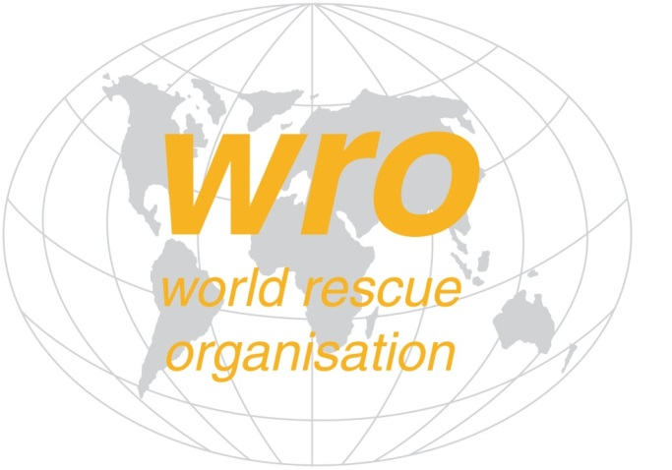

**World Rescue Organisation**



**World Rescue Organisation**

**Curriculum Vitae WRO/Doc/020/NVE/CV**

|  |  |
| --- | --- |
| PERSONAL INFORMATION | Replace with First name/s, Family name |
|  |  |
| [All CV headings are optional. Remove any empty headings.] | |
|  | Add Personal Photograph here  Replace with correspondence address |
| Replace with telephone number Replace with mobile number |
| State e-mail address  Replace with Skype Address or similar |
|  |

|  |  |
| --- | --- |
| Post/Position APPLIED FOR | Replace with post / position details |

|  |  |
| --- | --- |
| RELEVANT WORK EXPERIENCE FOR THE POST |  |

[Add separate entries for each experience. Start from the most recent.]

|  |  |
| --- | --- |
| **Replace with dates (from - to)** | Replace with occupation or position held |
| Replace with employer’s name and locality |
| * Replace with main activities and responsibilities |
| Business or sector Replace with type of business or sector |

|  |  |
| --- | --- |
| EDUCATION AND TRAINING |  |

[Add separate entries for each course. Start from the most recent.]

|  |  |  |
| --- | --- | --- |
| **Replace with dates (from - to)** |  |  |
|  | |
| * Replace with a list of principal subjects covered | |

|  |  |
| --- | --- |
| PERSONAL SKILLS |  |

[Remove any headings left empty.]

|  |  |  |  |  |  |
| --- | --- | --- | --- | --- | --- |
|  | |  |  | | --- | --- | | Replace with relevant skills applicable to the post being applied for |  | | Replace with a list of principal skills suitable to the post | | |

|  |  |
| --- | --- |
| Communication skills | Replace with your communication skills. Specify in what context they were acquired. Example:   * good communication skills gained through my experience as a manager |

|  |  |
| --- | --- |
| Organisational / managerial skills | Replace with your organisational / managerial skills. Specify in what context they were acquired. Example:   * leadership (currently responsible for a team of people) |

|  |  |
| --- | --- |
| Job-related skills | Replace with any job-related skills not listed elsewhere. Specify in what context they were acquired. Example:   * good command of quality control processes (currently responsible for quality audit) |

|  |  |
| --- | --- |
| Computer skills | Replace with your computer skills. Specify in what context they were acquired. Example:   * good command of Microsoft Office™ tools |

|  |  |
| --- | --- |
| Other skills | Replace with other relevant skills not already mentioned. Specify in what context they were acquired. Example:   * carpentry |

|  |  |
| --- | --- |
|  |  |

|  |  |
| --- | --- |
| ADDITIONAL INFORMATION |  |

|  |  |
| --- | --- |
| Publications  Presentations  Projects  Conferences  Seminars  Honours and awards  Memberships  References | Replace with relevant publications, presentations, projects, conferences, seminars, honours and awards, memberships, references. Remove headings not relevant in the left column.  Example of publication:   * How to write a successful CV, New Associated Publishers, London, 2002.   Example of project:   * Devon new public library. Principal architect in charge of design, production, bidding and construction supervision (2008-2012). |

|  |  |
| --- | --- |
| Time to commit to the post |  |

Replace with details on how you will be able to commit to the post

Provide details of any support you will receive from your employer

Provide details of any other areas of support you will receive

|  |  |
| --- | --- |
| The candidate by signing this document is giving an undertaking to commit to the work required by the WRO and the post. | I, (name of candidate) confirm that I will comit to undertake the work of (post here) in a professional maner and to the best of my ability.    Sign |

Name 

|  |  |
| --- | --- |
| Supporting Information |  |

|  |  |
| --- | --- |
|  | Replace with list of supporting information relative to the post |